***How to check-in code in TIMMDB***

These are the below steps to follow,

**Step 1:** Create local Branch

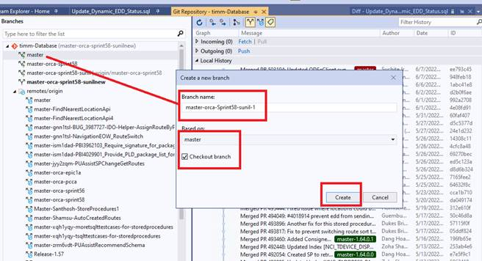

**Step 2:** Click Push button then your local branch will display under Remote/ origin section

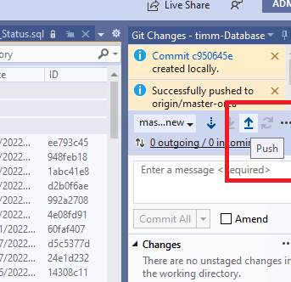

**Step 3:** Rename your local branch which is created under Master section

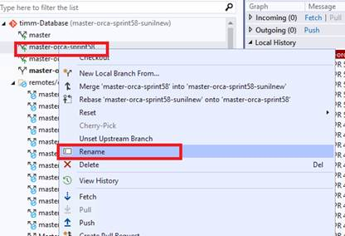

**Step 4:** Open solution explorer and modify files as per your defect / feature requirement.

**Step 5:** Modified files will display in team explorer “Changes” section.

                Add your comments in comments section as below format with “# Defect id”

                Then commit All button will be enabled.

If Commit All not enabled, then please configure your username in Git as highlighted.

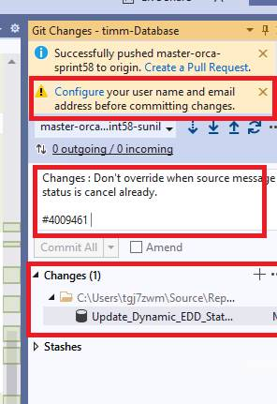

**Step 6:** Click push to origin

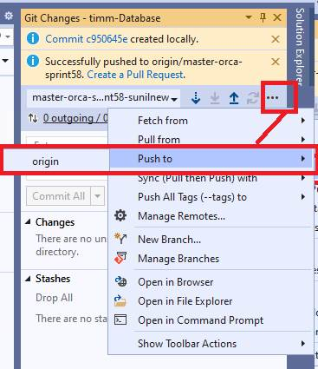

**Step 7:** Then below message will display.

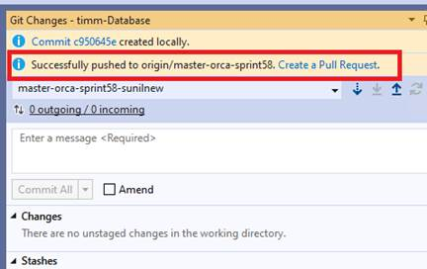

**Step 8:** Click to Create pull Request link will open in Chrome / any browser.

                Note: Copy this link may be use full for code review / you can send code review by filling all information

**Step 9:** Before step 8 maybe you can see your changes directly pushed to master.

**Note:** open defect and see below highlighted part if you see same comment as you added in GIT “means code checked in for your defect / feature.”

